Jersey
Employment and
Discrimination Tribunal

Annual Report
2023

This is the eighteenth Annual Report of the Employment and
Discrimination Tribunal and covers the period 1 January 2023 to 31 December 2023

Contents

Overview 3
Membership of the Jersey Employment and Discrimination Tribunal 4
Chairman’s Foreward 7
EDT Process………………………………………………………………............………. 9
Claims Submitted in 2023 10
Employment Law Claims………………………………………………………………….10
Discrimination Law Claims 11
Administration of Claims 12
Outcome and Awards..……………………………………………………….....……...…13
Contact Details……………………………………………...……………………...………16

Overview

The Employment and Discrimination Tribunal (‘EDT’) is an independent judicial body set up to hear and resolve claims and matters of dispute arising under the Employment (Jersey) Law 2003 (‘Employment Law’), the Employment Relations (Jersey) Law 2007 (‘Employment Relations Law’) and the Discrimination (Jersey) Law 2013 (‘Discrimination Law’).
The EDT is one of several Tribunals managed by the Judicial Greffe, the administrative arm of the Jersey Courts, through the Tribunal Service. The Judicial Greffe maintains budgetary control of the Tribunal’s day to day resources and the Minister for Social Security oversees the appointment of new panel members and also the introduction of employment and discrimination legislation and policy. The other Tribunals in the Tribunal Service are:-
- the Planning Tribunal;
- the Health and Safety Tribunal;
- the Social Security Tribunal, which is made up of three Tribunals, dealing with medical appeals, social security appeals and income support medical appeals;
- the Mental Health Review Tribunal and Capacity Tribunal; and
- the Charity Tribunal;

The Tribunal also maintains the Register of Trade Unions and Employers’ Associations registered in Jersey
The Tribunal itself is similar to a court but is less formal. Hearings are open to the public, although there are certain circumstances when hearings may be held in private. The Tribunal strives to provide a user-friendly service ensuring that the documentation and terminology used in its proceedings is easily accessible to all parties. The services of a translator are provided when required at no charge to a party.
The EDT’s Claim and Response forms, together with its User Guides and other explanatory information, are available on the EDT Service’s website: www.Tribunal.je
The EDT’s decisions are published on the Jersey Law website: www.jerseylaw.je/Judgments/JET
There is no fee required to submit a claim to the EDT and there are no costs awarded to either party at the end of the matter.

Membership of the Employment and Discrimination Tribunal
The Employment and Discrimination Tribunal consists of a legally qualified Chair and up to five legally qualified Deputy Chairs. There are also three pools of lay members who, depending upon the nature of the claim, will sit with a Chair.
The Chairs usually sit alone to hear unfair dismissal and breach of contract disputes but will sit with lay members for Final Hearings of discrimination claims and in more complex employment claims such as constructive unfair dismissal.
Discrimination and Employment Law Claims
Where a Claim Form contains claims arising under the Employment Law and the Discrimination Law a Chair may sit with two lay members drawn from:
- a pool of side members comprising of persons with knowledge of, or an interest in, trade unions or matters relating to employees; and
- a pool of side members comprising of persons with knowledge of, or an interest in, employers’ associations or matters relating to employers.
Discrimination Law Claims
When the EDT sits to hear just Discrimination Law claims a Chair will sit with two lay members drawn from a third pool of members which comprises a group of persons with knowledge or experience of, or an interest in, matters relating to equality and discrimination.
Discrimination claims can arise in a work and non-work setting. Non-work settings include the provision of goods and services, education and clubs.
Appointments
All appointments to the EDT are made following an open recruitment process overseen by the Jersey Appointments Commission in accordance with its published guidelines.
Once appointed, lay members remain entirely independent of their background; they do not represent any organisation with which they are associated and are entirely impartial, even though in work-related disputes they will have a background in either employer or employee matters.

Remuneration of Members
All members are paid a day rate for sitting on hearings.
Chairman – £736.00
Deputy Chairman – £552.00
Lay Members – £97.00

The members of the EDT in 2023 were:
Chair
Dr Elena Moran (Advocate)
Deputy Chairs
Advocate Ian Jones
Mr Michael Salter (Barrister)
Mrs Hannah Westmacott (Solicitor)
Advocate Fraser Robertson
Advocate Cyril Whelan
Panel members appointed to hear work-related claims:
Members with experience as representatives of employers | Members with experience as representatives of employees
Marilyn Wetherall | Lorraine Bennett
Sue Cuming | Simon Cross
Emma Harper | Clive Holloway
Simon Nash | Zannah Le Moignan
Michael De La Haye | Anne Southern
Roisin Pitman  Scott Hollywood  Claire Bowes | Jennifer Bridge  Patrycja Zakrzewska  Sue Pallot
Panel members appointed to hear non-work related claims of discrimination

Elizabeth Adams | Thomas Gales
Janet Brotherton | Mandlenkosi Mlambo
Melanie Cavey | Tamburi Muoni
Daria Sawicka

Chairman’s Foreword
The number of Claim Forms submitted to the EDT remains relatively constant with 232 Claim Forms submitted in 2023 compared to 209 in 2022.
The Claim Forms contained:
- 89 claims of unfair dismissal;
- 72 claims for unpaid wages;
- 66 claims for notice pay;
- 57 claims for holiday pay;
- 39 claims relating to non-provision of payslips; and
- 37 claims relating to non-provision of an employment contract;
In addition, 87 Claim Forms contained one or more claims of discrimination.
The most common claim made to the EDT is unfair dismissal including constructive unfair dismissal where the employee resigns because of the employer’s conduct. The number of unfair dismissal claims is slightly up from the 2022 figure of 80 claims. Most of the claims settle before a Final Hearing. Of the Final Hearings that took place in 2023 none of the constructive unfair dismissal claims and only 2 out of 8 of unfair dismissal claims were successful.
Claims for unpaid wages increased from 53 in 2022 to 72 in 2023. Most of the claims settled with 4 out of 11 claims being successful at a Final Hearing.
The claims for notice pay were down to 66 from 80 in 2022. Only 1 out of 10 claims was successful at a Final Hearing but again most cases settled or were withdrawn prior to that point.
There were less claims for holiday pay in 2023, 57 compared with 77 in 2022. This is due in part to less claims for bank holiday pay with employers seeming to have a better understanding around the bank holiday pay rules. Eight out of 10 claims were successful at the Final Hearing stage.
There has been a substantial drop in the number of claims for non-provision of payslips with 39 claims compared to 53 in 2022. Of the claims that reached a Final Hearing 6 out of 8 were successful. While the drop in the number of claims is encouraging it still reflects a persistent pattern of unlawful behaviour by a small number of mainly smaller employers. The current deadline of eight weeks from the end of employment to bring a claim is very short as tax and social security issues relating to non-provision of payslips can come to light months after employment has ended. This leaves employees with no effective remedy.
There has been a slight increase in the number of claims relating to non-provision of an employment contract with 37 claims compared to 31 in 2022. All the 6 claims that reached a Final Hearing were successful. As with payslips, non-compliance with the law on employment contracts is more an issue with smaller employers.
The number of Claim Forms with a discrimination claim submitted was 87 in 2023 compared to 82 in 2022. One incident included in a Claim Form can give rise to multiple discrimination claims where a Claimant has more than one protected characteristic. The most common protected characteristic giving rise to a discrimination claim was disability discrimination (55 claims), followed by sex discrimination (20 claims) and race (10 claims). Most disability claims arise from hidden disabilities such as neuro diversity and mental health issues.
One of the non-work-related discrimination claims involved a claim by a child against the Education Minister. This is the first time the EDT has dealt with a claim of discrimination in education since the Discrimination Law came into effect in 2013. The lack of education claims to date suggests that parents are unaware that the jurisdiction of the EDT extends to discrimination in education provision. For example, it includes exclusion from schools or school activities because of the symptoms of a child’s disability.
Most discrimination claims fail at a Final Hearing. Again, this probably reflects the fact that claims with obvious merit settle prior to the Final Hearing.
A particular success in 2023 has been the introduction of Alternative Dispute Resolution and judge led mediation that has led to informal resolution of several complex cases. Informal resolution provides the parties with greater control over the outcome and avoids the stress and costs of a Final Hearing.
Where claims fail at a Final Hearing they inevitably result in considerable time, effort and cost for the respondent. This is particularly the case with discrimination and constructive unfair dismissal claims where multiple acts spanning several years may need to be investigated. The EDT can only strike out a claim if it has no reasonable prospect of success. The lack of affordable legal advice in the later stages of a case means that claimants who feel aggrieved at their treatment but have an incomplete understanding of the law continue with cases that have little merit. This puts a huge burden on employers. Better access to cost effective quality employment law advice could alleviate this burden and would help support claimants with meritorious claims.
The EDT would not be able to function effectively without the work of the Registrars and the support that they provide to the parties. Their role is often made more difficult by parties failing to respond to enquiries or showing a lack of respect. Despite this the Registrars maintain a high standard of professionalism and I would like to thank them for their efforts and hard work.

Dr Elena Moran, Chairman

EDT PROCESS

The EDT process starts with a Claim Form being received which can include more than one issue. For example, a Claim Form may raise issues relating to unfair dismissal, unpaid wages and a failure to provide payslips.
The vast majority of Claim Forms are submitted by employees but occasionally by an employer.
The Claim Form is sent to the respondent who files a Response Form. In the Response Form the respondent may raise a counterclaim that the claimant must then respond to.
Where no response or response to counterclaim is filed to a claim the EDT may issue a judgment in default. This is only issued where the EDT has enough information to give judgment. In some cases, the EDT may give judgment on liability but order that there is a remedies hearing at a later date.
Once all the necessary forms have been submitted cases are stayed and referred to conciliation/mediation. All claims involving employers are referred to the Jersey Advisory and Conciliation Service, and non-work-related discrimination claims are referred to Citizens Advice Jersey.
Where a case does not settle at mediation it is listed for a short case management meeting before a Chair to give orders for the progress of the case. At this point the parties may be offered the option of alternative dispute resolution (ADR) in the form of judicial mediation. ADR allows the parties to explore settlement with the assistance of an experienced employment judge.
A case is listed for an interim hearing where it is necessary to resolve whether the EDT has jurisdiction. For example, to determine if a Claimant is an employee or is self-employed, or if the claim has been submitted in time.
A Final Hearing is presided over by a single chair or a panel of three in more complex employment cases and discrimination claims.
Normally remedies are determined at the Final Hearing but where this is not possible a separate remedies hearing may be arranged.
The Chairs aim to issue the written judgment to the parties within six weeks of the Final Hearing.

Claims Submitted in 2023

In 2023 a total of 232 Claimants submitted Claim Forms to the EDT raising claims under the Employment Law and Discrimination Law. There were no claims under the Employment Relations Law

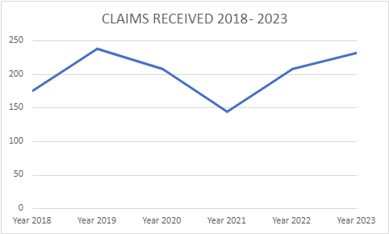

Employment Law Claims

Employment claims often comprise of several different issues at Claim Form submission stage.

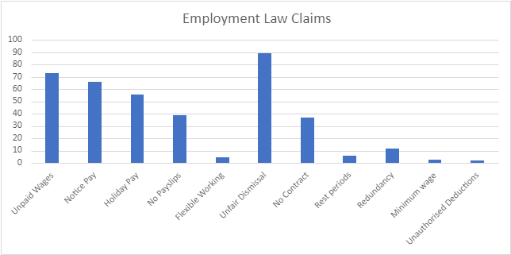

Discrimination Law Claims

There were 87 Claim Forms submitted in 2023 that had one or more discrimination claims.

Claims by protected characteristics:
The 87 Claim Forms filed contained 102 allegations of discrimination. Disability discrimination was the most common Protected Characteristic cited and accounted for 55 of the 102 claims. The second most common Protected Characteristic was Sex followed by Race.

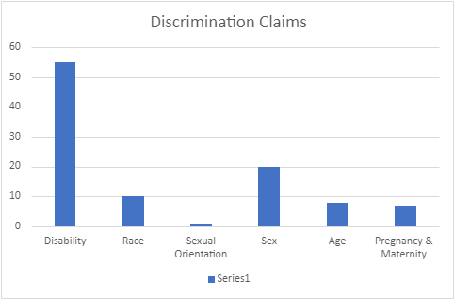

Disability – includes long term physical, mental, intellectual or sensory impairments which can adversely affect ability to engage or participate in activities protected under the Discrimination Law.

Race – includes colour, nationality, national and ethnic origins.

Sex – includes gender re-assignment

Of the 87 Claim Forms filed, 16 contained allegations of discrimination in a non-work setting. 10 of the 16 Claim Forms were brought by the same Claimant. The rest of the allegations arose in a work setting.

Administration of Claims

The EDT conducted 149 hearings during 2023. Hearings are conducted in person, by phone or by video link. Phone and video hearings take place for several reasons such as parties or representatives being off island and health issues.

Number of hearings in 2023:

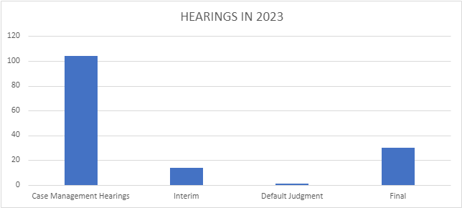

Use of Interpreters
The services of an interpreter are provided by the EDT when required for hearings. This facilitates the smooth running of hearings and ensures fairness.

Interpreters are paid £82.00 - £224 depending on the length and type of the hearing.
In 2023 19 parties indicated on their forms that they would require the assistance of an interpreter.

Language of interpreter indicated on the Claim Form:

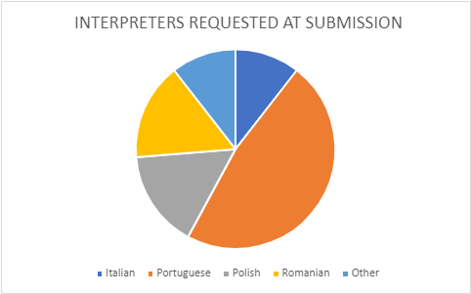

Representation of Parties
Out of 232 cases filed in 2023, 54 claimants and 85 respondents engaged representatives to assist them at form submission stage.
Out of 32 Final Hearings in 2023, 1 claimant and 9 respondents were represented at this stage.
Claimants were assisted by a range of representatives including friends and family, HR professionals and in a few cases lawyers, either locally qualified or qualified abroad.
Most representatives for respondents were other professionals e.g. HR Consultants

Outcomes & Awards
Judgments
The EDT aims to issue a judgment to the parties within 6 weeks of the Final Hearing. All but 6 of the Judgments delivered in 2023 were delivered to the parties within 6 weeks of the hearing.
Outcomes of Final Hearings
There were 31 Final Hearings in 2023 including 13 from Claim Forms submitted in 2022. In one case the judgment is still outstanding.
In some cases, both parties were successful on different issues.
The table below shows the outcome only in relation to claims that were still in dispute at the Final Hearing. Some claims may have been withdrawn or struck out prior to the Final Hearing. Where a Claim Form includes multiple discrimination claims arising from the same protected characteristic the table records if the Claimant was successful on at least one of those claims. A discrimination claim on a protected characteristic would also include any related claims of victimisation and harassment.

Claims | In Favour of Claimant | In Favour of Respondent
Unfair Dismissal | 2 | 6
Constructive Unfair Dismissal |  | 5
Notice Pay/Wrongful Dismissal | 1 | 9
Holiday/Bank Holiday Pay | 8 | 2
Unpaid Wages | 4 | 7
No Contract | 6
No Payslips | 6 | 2
Minimum Wage | 1
Rest Periods |  | 2
Sex Discrimination | 1
Race Discrimination |  | 6
Age Discrimination |  | 1
Disability Discrimination | 1 | 2
Counterclaims | 3 | 1
Other | 2 | 1

The EDT awards damages for successful breach of contract claims (i.e. failure to pay holiday/bank holiday pay, wrongful dismissal (notice pay), unpaid wages, commission, bonuses).

The EDT awards compensation for successful statutory claims (i.e. unfair or constructive unfair dismissal, discrimination, failure to provide pay statements, failure to provide contract, failure to allow representation at disciplinary hearing etc).

During 2023 the total amount awarded by the Tribunal was £85,148.56. This was made up of £56,789.58 in compensation and £28,358.98 in damages.

Outcomes of claims as at 31 December 2023
The EDT aims to resolve all claims within 6 months of receipt of the Claim Form. Sometimes this is not possible due to the complexity of the issues in the case, the health of the parties, insolvency of a party or related criminal proceedings.
232 Claim Forms were submitted in 2023. By the end of the year 10 had been to a Final Hearing and 82 remained ongoing.
The majority of the remainder were either settled or withdrawn.
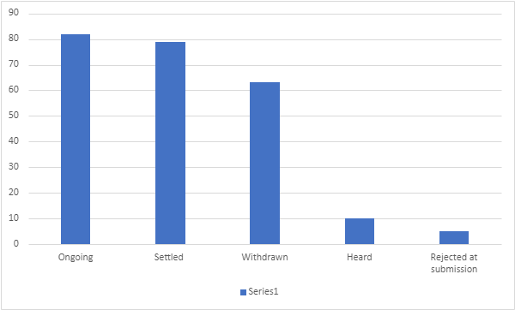

At the end of 2023:-
5 claims remained unresolved from 2022 due to the Respondent company being in liquidation and a further 3 cases remained ongoing due to their complexity.
One case from 2021 was still outstanding, the delay reflecting the time taken to implement a settlement agreement.

Contact Details

Address:

1st Floor, International House, 41 The Parade, St Helier, Jersey, JE2 3QQ

Opening hours

Monday – Friday
09:00-17:00

Telephone

(01534) 441380

Email

registrartribunalservice@courts.je

Website

http://www.tribunal.je

Team Members

Manager – Tracey Pearce (Main Responsibility – Employment & Discrimination Tribunal)

Registrar – Janet Smith (Main Responsibility – Mental Health Review Tribunal, Capacity Tribunal & Social Security Tribunal)

Registrar – Helena Nensen-Whelan (Main Responsibility – Planning Tribunal)

